Protective Measures

Using Antiviruses

It is one of the utmost tasks to set up an antivirus in order to protect your device from malware and dangerous creatures,

There is a special tool called Virus Total which used on the web to scan malicious links, files, ip addresses, and file hashes using more than 70 anti-viruses, think of it as a software that uses other anti-viruses to scan all at once.

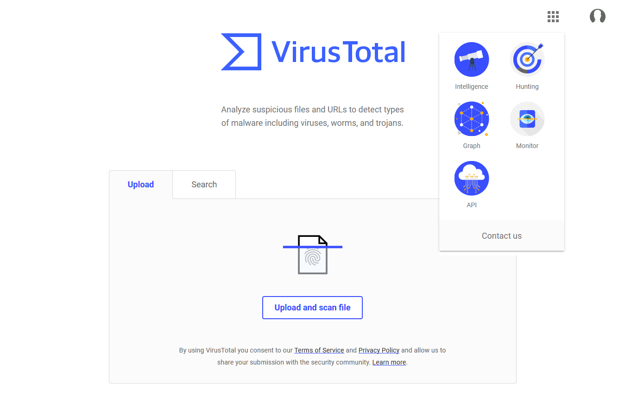

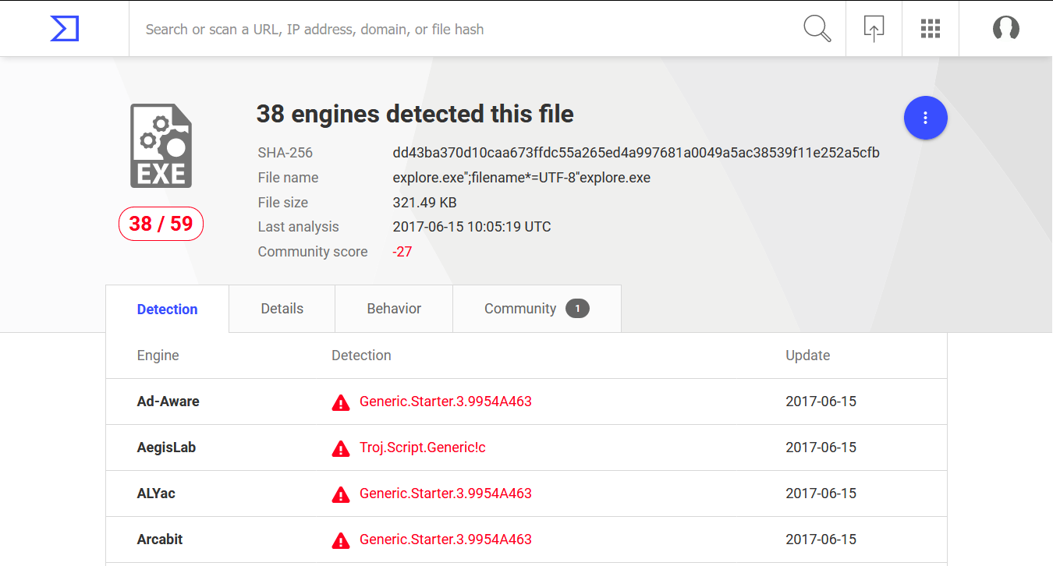

**Set up a browser: The secure way.**

**The most common-sense part of this is to keep your browser software up-to-date.**

**Manage and disable plugins that are deemed to be malicious.**

**Always connect to websites using HTTPS.**

**Clear browser history including cookies, as those are the most prime victim of a cyber attacker, they contain information about you that is confidential like your password.**

**Stop saving your password, it is easily susceptible to being stolen.**

**Set Up an Email: The Secure way.**

**SMTP provides no security mechanism by default**

**Encrypt your emails by making sure the server you’re connected to is required to connect using SSL, an encrypted connection.**

**Make sure the emails you receive and click on are from a trusted source.**

**Still, inherently speaking, sending mails by email is insecure and is susceptible to the man in the middle attack.**

**Firewall**

**Keep it on!**

**Only allow applications/processes that you know are legitimate!**

**Set a rule to stop the browser from connecting to HTTP.**

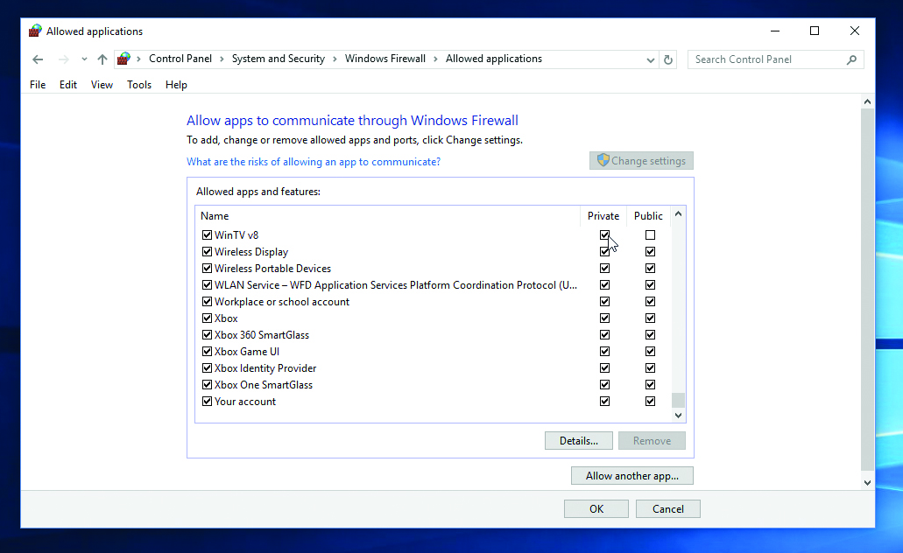

**Some Common Sense**

**Use Passwords, Strong passwords.**

**Don’t share your password.**

**Don’t click on links you don’t trust.**

**Don’t download things you don’t trust**

**Always google about anything you’re doing/downloading.**

**Log out off your accounts on websites.**

**Don’t save passwords. IF you really want to, use a password manager.**